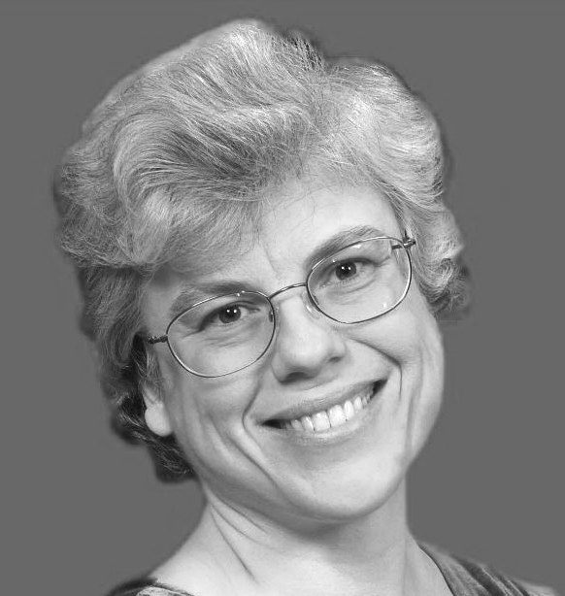
Anne Barschall anne@barschall.com 914-393-3243 (c)
URL: barschall.com belt-G; mix-E; legit-B♭
Hair/Eyes:White/Brown Weight: 145 lbs Height: 5’7”
Video/film/TV
Mysteries at the Museum Ida Rosenthal Travel Channel
Grave Secrets Miriam Tiaffay Investigation Discovery
Un Vase a Chinatown Mme Paula d Jeremy Hung
Cobblestone Corridor Health Instructor d Erik Bloomquist, Connecticut Public TV
The Visitor Grandmother d Katya O’Brian
Failing with Grace Nun d. Matthew Mayer
Theatre
Drinking Habits Sister Augusta d Joseph Gasparini, Clove Creek Dinner Th
A Bad Year for Tomatoes Willa Mae Wilcox d Jake McGuire, Clove Creek Dinner Theater
Murder on the Nile Helen Ffoliot-ffoulkes d Billy Peck, Alpha NYC
Lady Sketch Lab Narrator, passenger Magnet Theater
Cinderella Stepmother d Elizabeth Ann Figols, AlphaNYC
“Angel in the Woods” Viper St. Cloud d Daniel Ahrens, PIT
Monologues Various Pim Shih, The Set NYC
The Birth of My Second Child Personal Story d Adam Wade, Magnet Studio
Elissa Dauria Show Personal Story Theater Under St. Marks
Comedy & Musical Improv
Team Meaningful Touch Musical Improv comedy d Nikita Burdein, Magnet
Series of 3 shows Comedy/improv d Eric Tanouye, UCBeast
Team John Lennon’s Shoes Comedy Improv d Scotty Watson
Team Special Socks Comedy/Improv d Sebastian Conelli
Musical mixers Musical Improv Comedy Magnet, Pit, QSIC
Voiceover
Atlantis Bearer of Fruits Narrator & Ahteana d David Speight
Mad Father Movie Maria d Dolly Strawberry
Musical Theater
“The Sinking Ship” Anne Issa Berg d Daniel Ahrens, PIT
Training
- Studying comedic and musical improv since 2013 at The Magnet Theater, UCB and AND. List of courses taken http://tinyurl.com/hgeqq8z
- Acting – Wynn Handman, Steve Reidel, Caymichael Patten, Vicky Kact, T.J. Mannix
- Voice & Musical Theater(J Lehman, B Ross, S Blackall, M Wilson, M Mechalakos, A Whitehead
- List of casting directors I’ve taken courses from: http://tinyurl.com/zmcknf7
Education
- J.D. Columbia Law School, NY, Harlan Fiske Stone scholar in 3rd year
- International Fellows Program, Columbia School of International and Public Affairs, NY
- B.A. Physics, Dartmouth College, NH, magna cum laude, distinction in major
- Baccalaurėat C français mention assez bien
Special Skills/ Other Experience
- Extensive public speaking & story telling in spiritual/religious groups
- Made it to round 3 in X Factor auditions in 2012, Providence, Rhode Island; vocal solos in churches
- Patent Attorney (33 years)/technical writer/science & technology/computers
- Languages: French fluent; Spanish working knowledge; Russian decent pronunciation; multiple accents
- misc: driving, calligraphy, yoga, 2 special needs sons, hiking, social media (facebook, twitter, linkedin), managed mini nursing home in mom’s home for 8.5 years; both US & EU passports, basic piano, sight reading; wrote 3 novels
COMMERCIALS AND INDUSTRIALS AVAILABLE ON REQUEST

